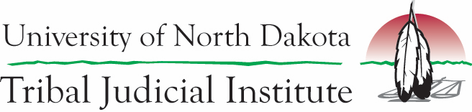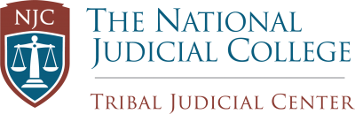

Emerging Issues in Tribal Courts
“Enhancing Tribal Justice Systems and Supporting Tribal Sovereignty.”

January 11-12, 2024
Seattle, Washington

The Emerging Issues conference will provide tribal justice system officials with recent legal updates impacting tribal courts and tribal justice systems and strategies to improve tribal court operations within tribal justice systems. Some of the topics that will be addressed at this conference will include:
- Impact of Haaland v Brackeen on tribal courts and tribal justice systems.
- Criminal jurisdiction updates to include and examination of Oklahoma v. Castro-Huerta and United States v. Cooley.
- Separation of powers for tribal justice systems.
- Substance misuse treatment modalities.
- Improving interactions between tribal justice programs and the community.
- Effective court administration and operations.

Who should Attend?
- Affiliates of federally recognized tribes working in tribal justice systems including tribal leaders, tribal court judges, tribal court clerks and administrators, tribal prosecutors and attorneys, diversionary court personnel, and other tribal justice system officials.

Registration: This event is free for all participants. However, each participant is responsible for their own travel costs. To register for this event: https://und.qualtrics.com/jfe/form/SV_8ukXjmQ4p4BDpFs

Lodging details will be forthcoming.

Important Note: This event is pending DOJ approval and is subject to cancellation.

